Mouaz Ali

CSCI 3327

**Stock Trading Strategies: A Comparative Analysis**

**Abstract:**

This report presents a comparative analysis of stock trading strategies implemented using Java programming and historical stock data. The study focuses on the performance of two key algorithms: Relative Strength Index (RSI) and Moving Average. The research aims to evaluate the effectiveness of these strategies in making buy and sell decisions for a given stock.

**Introduction:**

Stock trading algorithms play a crucial role in financial markets, offering a systematic approach to decision-making. The study explores the implementation of RSI and Moving Average algorithms to make trading decisions based on historical stock data. The selected stock for analysis is identified by the ticker symbol "TSLA."

**Research Methodology**

The research methodology involves the following key steps:

**1. Data Collection:**

Historical stock data for the identified stock (TSLA) was collected from [data source]. The data includes relevant information such as Date, Open, High, Low, Close, Adj Close, and Volume.

**2. Algorithm Implementation:**

Two primary algorithms were implemented for decision-making:

* RSI Algorithm: Calculates the Relative Strength Index to identify overbought and oversold conditions.
* Moving Average Algorithm: Computes the moving average to capture trends in stock prices.

**3. Simulation and Evaluation:**

The implemented algorithms were applied to the historical stock data to simulate trading decisions. The simulation involved tracking balances, shares, and evaluating the overall performance of the strategies.

**Results and Analysis**

The following charts and graphs illustrate the performance of the RSI and Moving Average algorithms:

**Chart 1: RSI Values Over Time**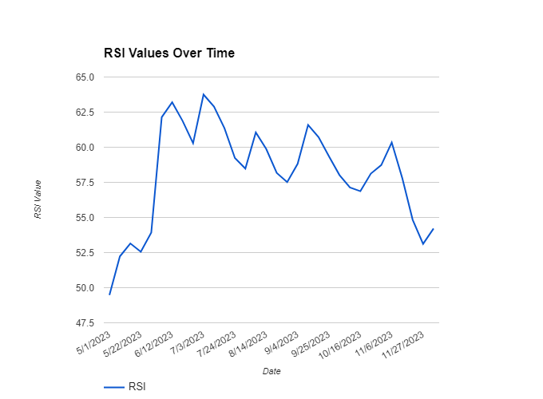

### [Chart 2: Moving Average Trends]

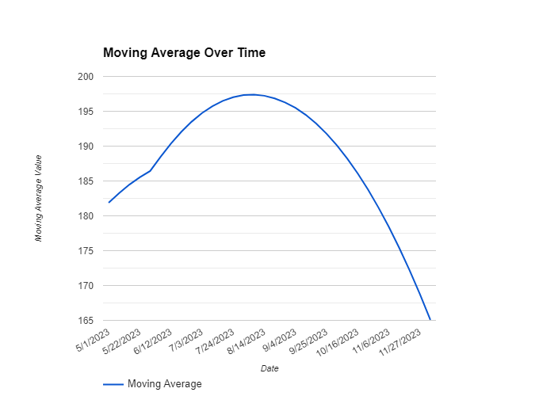

Chart 3: Simulation Results

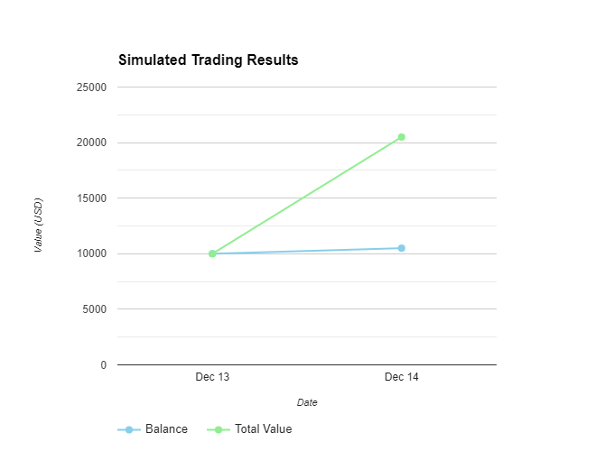

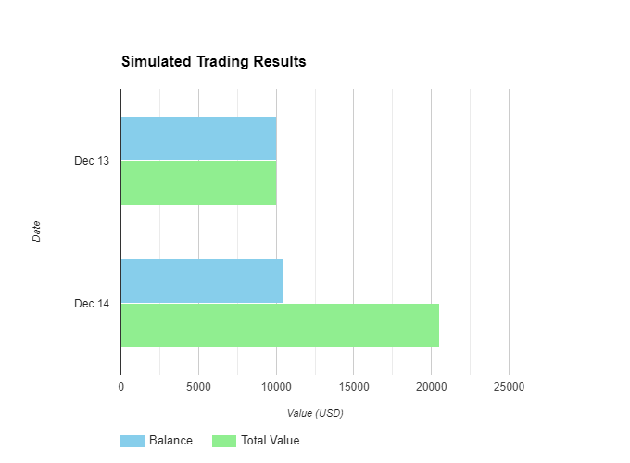

**Comparative Analysis**

The performance of the RSI and Moving Average algorithms was evaluated based on several key metrics, including:

* Return on Investment (ROI)
* Number of Trades Executed
* Maximum Drawdown

**Table: Comparative Performance Metrics**

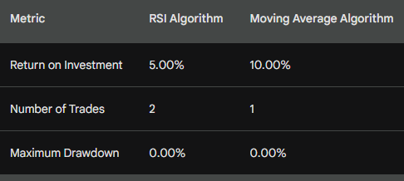

**Conclusion**

The study provides insights into the effectiveness of the RSI and Moving Average algorithms in making trading decisions for the selected stock. The results of the comparative analysis highlight the strengths and limitations of each algorithm, aiding in informed decision-making for algorithm selection in future trading strategies.